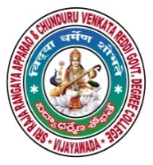 | SRR & CVR GOVERNMENT DEGREE COLLEGE  (AUTONOMOUS)  VIJAYAWADA, KRISHAN DIST., A.P  NAAC B+GRADE(CGPA:2.60) | 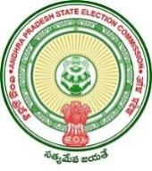

Nehru Youth Sangatan
Date: 08-03-2022
- Nehru Youth Sangatan day held on SRR & CVR college (A), Vijayawada

- Resource person: Dr. B. Sudhakar and respected Lecturers .

- Chief Patron: B.J Prasanna .

- Events: issued certificates.

Nehru youth Sangatan was held in Dhanekula engineering and technology auditorium to inspire the students to acquire the leadership qualities. District level cyberhood youth parliament started this program. They bring awareness about government schemes like (Beti Bachavo and Beti Padavo), startups, youth skills, children’s welfare, minorities welfare and township , digital education, health, swatcha bhara etc. There was a lot of discussion on this topics. On this occasion, the chief guest, Sri B.J Prasanna garu addressed the gathering to improve their leader ship qualities. Dr . B Sudhakar, Lecturer in commerce, SRR and CVR GDC(A), VJA spoke on this occasion and emphasised the need to organize this kind of programs.

